User’s Manual

By Seth Everett

The Basics:

Open program by running executable program.

* 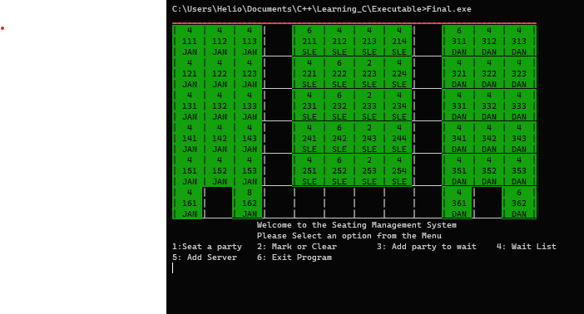Upon opening the program, you should see a similar sight to this:

This is the basic command line interface.

The Program consists of 6 functions

1. Seat a Party 2. Mark or Clear 3. Add Party to Wait 4. Wait List 5. Add Serve 6: Exit Program

Seat Party

Seat Party allows the used to assign guests to a particular table.

Directions

1. Type, 1, into the prompt.
2. The Screen will clear, and you will be prompted to enter the table you wish to seat.
3. Type the desired table into the prompt.
4. Next you will need to the enter the number of guests.
5. If the table can handle that enter number of people, the screen will clear and display the home table.
   1. If the table cannot hold that number of people, the user will be prompted too either.
      1. A: Continue B: Enter a smaller party amount C: Select a different table
   2. If you select continue the program will clear and go to the home table.
   3. If you selected Enter a smaller party amount you will be repromoted to enter a smaller party amount.
   4. If you selected the select a different table, you will be prompted to select a different table then asked again for the number of people within the party.

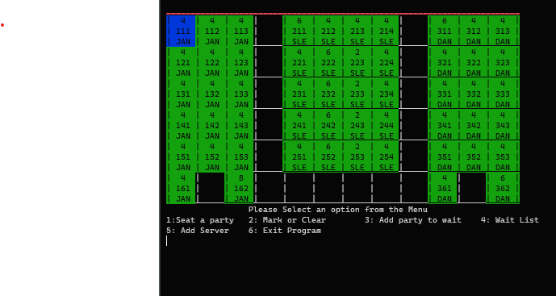Upon competition the program should look like this.

Mark or Clear

Allows the user to mark a table yellow or to clear a table back to green.

Directions

1. Enter, 2, in the prompt.
2. The user is then prompted to select either:
   1. Clear Table or Mark table dirty
3. Enter either 1 or 2.
4. Once selected the user will need to input the table they wish to modify.
5. Once enter the screen will clear and the user will be taken back to the home table.

If following from the previous example on how to seat a table the table will now look like.

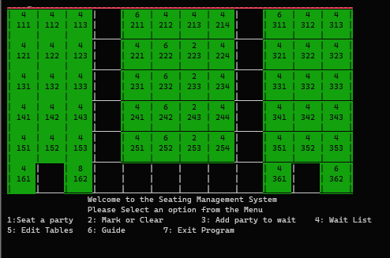

Add Party to Wait

Allows the user to add a guest to the wait.

Directions

1. Enter 3 into the prompt.
2. The user will be showing this page which shows all five of the wait list slots

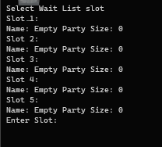

1. The user will need to select a slot and enter the corresponding number of that slot.
2. Once selected the user is prompted to enter the name of the party.
   1. This must a single word, no spaces are allowed.
3. The user will then be prompted for the party size.
4. The user will then be prompted if there are any special requests such as wall, window, or table number.
   1. The user must enter with a capital Y or N if they want to enter a special request.
5. If the special request is selected the user will then be promoted to enter it.
   1. This must be a single word; no spaces are allowed.
6. Upon enter this information the user will be taken back to the home table.

Waitlist

Allows the user to view the wait list.

Directions

1. Enter 4 into the prompt.
2. Upon entering the user will be taken to a list of the 5 wait list slots
3. To exit the list the user must enter a num whole number into the prompt.
4. The user will be taken back to the home table.

Add Server

Allows the Users to modify the initials of the server in each Dining Room

Directions

1. Enter 5 into the prompt.
2. The user will be greeted with a list of the three server slots and their assigned dining room.
3. Enter the number associated with the slot.
4. The User will then be prompted to change the initials of the server,
   1. Must be 3 letters.
5. Once enter the user will be taken back to the home table.

Exit Program

Allows the user to end the program.

Directions

1. Enter 7 into the prompt.
2. Upon enter the user will exit from the program and the home table will be cleared off the screen.